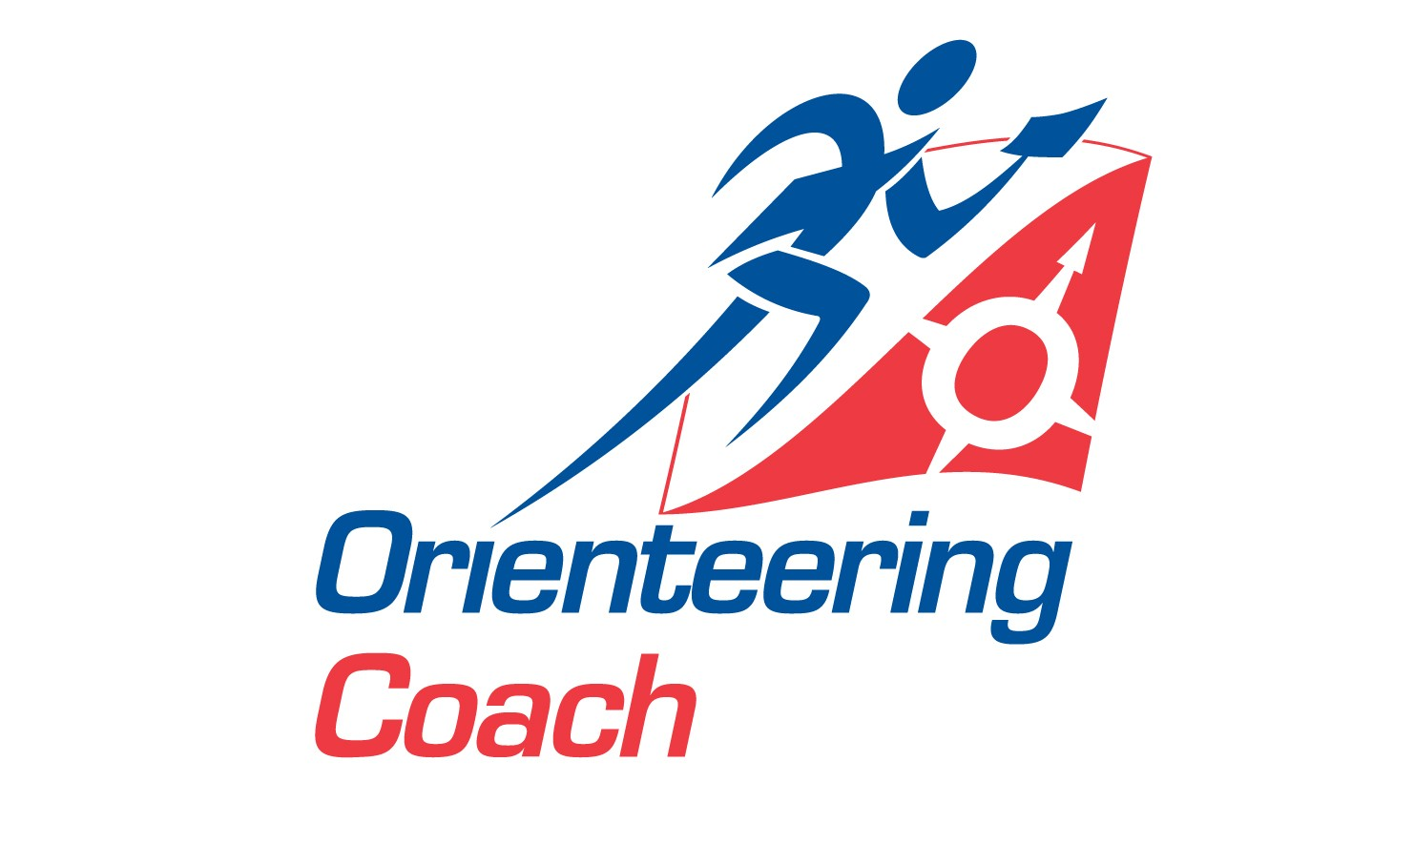_____________________________________
Registered Office
8a Stancliffe House, Whitworth Road, Darley Dale, Matlock, Derbyshire DE4 2 HJ

Phone: 01629 734 042 Fax: 01629 733 769
Email: info@britishorienteering.org.uk
www.britishorienteering.org.uk

British Orienteering Coaching Day for Individual’s
Cordon and Stapeley, Shropshire (15 miles from Shrewsbury)
Saturday June 7th (9.30am to 3pm) 2008
(Sunday June 8th HOC National Event – Brown Clee)
Managed and planned by Ruth Lockley and Andy Hemsted
We are arranging a Coaching Day which is open to all British Orienteering individual members.
The day will be planned and managed by Ruth Lockley and Andy Hemsted. Some of Britain’s most qualified coaches will instruct you on training exercises to help you improve your orienteering technique.
According to your standard participants will be divided into groups on the day:-
1) Orange/level 3 2) Lt Green/level 4 3) Green+ / Level 5.

Applications will be accepted from any individual British Orienteering member and will be strictly on a first come first served basis; a reserve list will be used if necessary.
The cost for the coaching will be a total of £10 per adult, £5 for juniors. This covers the coaching fees, maps, descriptions and land access fees.

Final details will be dispatched by email or in the post by May 23rd although I can tell you the venue lies between Corndon Hill and Stapeley, full travell directions later.
Vicky Thornton (Coaching Manager)
Note:- This same day will also be open for club coaching (ie if a club wishes to attend bringing a group and using it’s own coaches) – please refer to the separate British Orienteering Coaching Day Application Form for Clubs in order to apply.


British Orienteering Coaching Day for Individual’s

Saturday June 7th 2008 Cordon and Stapeley
Please use one application form per participant
Name……………………………………..Age if Junior (17yrs &under)……………….......
Membership number …………………..Club……………Standard……………………….
Address…………………………………………………………………………………………
Phone Number……………………..Email……………………………………………………
I enclose a cheque payable to British Orienteering of £10 senior/£5 junior …..

To be returned by Wednesday May 21st at the latest.

